Pharmaceutical pricing and reimbursement systems in countries of the former Soviet Union

  - Report of the Pharmaceutical Pricing and Reimbursement Information network for countries of the Commonwealth of Independent States, 2018

Abstract

Keywords

PHARMACEUTICAL POLICY

INSURANCE, HEALTH,

PRICING, REIMBURSEMENT

ACCESS TO MEDICINES

PHARMACEUTICALS

EUROPE

Contents
List of figures and tables 4
Figures 4
Tables 4
Authors 5
Acknowledgements 5
Abbreviations 6
Executive summary 7
Aim and methods 7
Key findings 7
Conclusions 9
1. Introduction 10
2. Methods 10
2.1 Countries included in the analysis 10
2.2 Terminology and indicators 11
2.3 Data survey and validation 11
3. Comparative analysis 12
3.1 Health system organization and funding 12
3.2 Pharmaceutical policy framework 14
3.3 Key data on the pharmaceutical system 15
3.4 Pricing policies in the outpatient sector 16
3.5 Pricing and procurement policies in the inpatient sector 23
3.6 Reimbursement policies 23
3.7 Responsible use of medicines 28
3.8 Generic policies 31
4. Conclusions 32
References 34
Annex 1. Access to HIV, hepatitis and TB medicines in eastern Europe and central Asia 36
Contents 36
Abbreviations 36
Introduction Fehler! Textmarke nicht definiert.
Country profiles Fehler! Textmarke nicht definiert.
Intercountry comparisons 49
Annex 2. Glossary Fehler! Textmarke nicht definiert.

List of figures and tables

Figures
Fig. 3.1. Existence of national medicine policy in CIS PPRI network countries, 2018 14
Fig. 3.2. Price regulation of outpatient medicines in CIS PPRI network countries, 2018 17
Fig. 3.3. Use of EPR as pricing policy for outpatient medicines in CIS PPRI network countries, 2018 18
Fig. 3.4. VAT rates on medicines, compared to other goods, in CIS PPRI network countries, 2018 23
Fig. 3.5. Central, regional and individual procurement of inpatient medicines in CIS PPRI network countries, 2018 23
Fig. 3.6. Existence of NEMLs in CIS PPRI network countries, 2018 23
Fig. 3.7. Reimbursement lists for outpatient and inpatient medicines in CIS PPRI network countries, 2018 25
Fig. 3.8. Patient payments for publicly subsidized outpatient and inpatient medicines in CIS PPRI network countries, 2018 27
Fig. 3.9. Use of HTA in CIS PPRI network countries, 2018 27
Fig. 3.10. Utilization of managed entry agreement in CIS PPRI network countries, 2018 28
Fig. 3.11. Prescribing by INN and generic substitution in CIS PPRI network countries, 2018 32

Tables
Table 3.1. Organization and funding of the health care system in CIS PPRI network countries, 2018 13
Table 3.2. Key authorities for marketing authorization, pricing and reimbursement of medicines in CIS PPRI network countries, 2018 14
Table 3.3. Data on pharmaceutical production, market and funding of medicines in CIS PPRI network countries, 2018 (or latest year available) 15
Table 3.4. Price regulation and pricing policies in CIS PPRI network countries, 2018 18
Table 3.5. EPR as pricing policy for outpatient medicines in CIS PPRI network countries, 2018 19
Table 3.6. Pricing policies in the supply chain: wholesale and pharmacy remuneration regulation and VAT on outpatient medicines, 2018 22
Table 3.7. NEMLs in CIS PPRI network countries, 2018 24
Table 3.8. Reimbursement lists for medicines in CIS PPRI network countries, 2018 26
Table 3.9. Prescription monitoring and clinical guidelines in CIS PPRI network countries, 2018 29

[Reference made to figures, maps and tables – marked in red]

Authors
This report was written by Sabine Vogler and Nina Zimmermann (WHO Collaborating Centre for Pharmaceutical Pricing and Reimbursement Policies, Austrian Public Health Institute), Guillaume Dedet, Janice Lam and Hanne Bak Pedersen (WHO Regional Office for Europe), based on information provided by national competent authorities on pricing and reimbursement policies in members of the Pharmaceutical Pricing and Reimbursement Information network for countries of the Commonwealth of Independent States.

Acknowledgements
The authors would like to express their appreciation to the following people for their inputs to the report:
- representatives of competent authorities responsible for pharmaceutical pricing and reimbursement (members of the Commonwealth of Independent States (CIS) Pharmaceutical Pricing and Information (PPRI) network) for providing information and data about pharmaceutical policies in their countries, writing a brief country profile and, in particular, for reviewing their country’s data in the final report;
- representatives of competent authorities gathered during the CIS PPRI network meeting held in Baku, Azerbaijan, on 15 and 16 May 2018, for providing information and data about their pharmaceutical systems by writing a brief country profile;
- Ogtay Gozalov, Antons Mozalevskis and Elena Vovc (Joint Tuberculosis, HIV/AIDS & Hepatitis Programme, WHO Regional Office for Europe) and to Ihor Perhinets and Regina Winter (Division of Health Systems and Public Health, WHO Regional Office for Europe);
- Gayane Ghukasyan (WHO Country Office in Armenia), Javahir Suleymanova (WHO Country Office in Azerbaijan), Viatcheslav Grankov (WHO Country Office in Belarus), Nino Mamulashvili (WHO Country Office in Georgia), Saltanat Yegeubayeva (WHO Country Office in Kazakhstan), Kaliya Kasymbekova and Saltanat Moldoisaeva (WHO Country Office in Kyrgyzstan), Stela Gheorghita (WHO Country Office in the Republic of Moldova), Sergei Deshevoi (WHO Country Office in the Russian Federation), Zulfiya Pirova and Abdulakhad Safarov (WHO Country Office in Tajikistan), Leyla Imamkuliyeva and Ayjeren Myratdurdyyeva (WHO Country Office in Turkmenistan), Alexey Bobrik and Svitlana Pakhnutova (WHO Country Office in Ukraine) and Zafar Fayziev, Jamshid Gadoev and Khurshid Ibatov (WHO Country Office in Uzbekistan) for their significant contributions to this work;
- Lydia Wanstall, WHO consultant, for copy-editing.

Abbreviations
CIS | Commonwealth of Independent States
EPR | external price referencing
HTA | health technology assessment
INN | international nonproprietary name
MHIF | mandatory health insurance fund
NEML | national essential medicines list
NHS | national health service
OOP | out-of-pocket [payment]
PPRI | Pharmaceutical Pricing and Reimbursement Information [network]
SHI | social health insurance
TB | tuberculosis
UHC | universal health coverage
VAT | value-added tax

Executive summary

Aim and methods
The Pharmaceutical Pricing and Reimbursement Information (PPRI) network aims to exchange policy information and share experiences among competent authorities in the field of pharmaceutical pricing and reimbursement in 46 countries. The Commonwealth of Independent States (CIS) PPRI network is a regional subgroup for countries of the former Soviet Union: Armenia, Azerbaijan, Belarus, Georgia, Kazakhstan, Kyrgyzstan, the Republic of Moldova, Tajikistan, Turkmenistan, Ukraine and Uzbekistan (not all of which are formally members of the CIS).
Given the lack of literature and information about the pharmaceutical policy framework – particularly related to pricing, purchasing and funding of medicines – in countries of the former Soviet Union, this report aims to provide a comparative overview of their pharmaceutical pricing and reimbursement systems.
A specific focus on access to HIV, hepatitis and tuberculosis (TB) medicines in countries in eastern Europe and central Asia can be found in Annex 1. This highlights the different stages of transition in funding and procurement of HIV, hepatitis and TB medicines from international partners such as the Global Fund to Fight AIDS, Tuberculosis and Malaria to national competent authorities. The extent of coverage is also outlined in intercountry comparisons; these serve as basis for future action to increase and/or sustain access to these medicines.
This report was mainly informed by data provided by CIS PPRI network members through a national profile, using a template developed by the PPRI network, that each country was asked to complete.

Key findings
In the majority of the countries examined, health care is based on a single-payer national health service. Countries have made major progress towards universal health coverage and offer significant coverage of health care, although only for a limited set of health services. In many countries health care reforms are ongoing.
Several countries (such as the Republic of Moldova and Uzbekistan) have a national medicines policy in place, and a legal framework regulates coverage of medicines in all countries surveyed.
The number of medicines with a valid marketing authorization varies between approximately 4300–4500 in Azerbaijan, Armenia, Belarus and Tajikistan and 12 000 in Georgia. In Belarus, Turkmenistan and Ukraine, locally produced medicines account for important market shares, whereas local production appears to play a minor role in other countries of the former Soviet Union.
Out-of-pocket payments for health care are high, and medicines are one of the key drivers of patient payments.
Seven countries (Azerbaijan, Belarus, Kazakhstan, the Republic of Moldova, Turkmenistan, Ukraine and Uzbekistan) have a form of price regulation in place for some outpatient medicines (usually a small group). In five of these, this entails full regulation at all price levels (ex-factory prices as well as wholesale and pharmacy retail prices through distribution margins), while in Belarus and Turkmenistan only distribution margins are regulated. Armenia, Georgia, Kyrgyzstan and Tajikistan have no form of price regulation for outpatient medicines (apart from price setting where central procurement is undertaken).
All five countries with full price regulation apply the policy of external price referencing (EPR), which is based on comparisons with prices in other countries. Country benchmarking baskets tend to be large and usually include European countries. The benchmark price determined through EPR corresponds either to the lowest price found in the reference countries or to a weighted average. Countries that introduced EPR reported reductions in medicine prices. Internal reference pricing (i.e. with reference to the price of identical or similar medicines within the country), or a variant of it, is only applied in the Republic of Moldova and Ukraine.
Seven (Azerbaijan, Belarus, Kazakhstan, the Republic of Moldova, Turkmenistan, Ukraine and Uzbekistan) of the 11 countries surveyed have or will have regulated wholesale and pharmacy remuneration. The scope of regulation of wholesale and pharmacy remuneration addresses all (authorized) medicines in some countries – not only those reimbursed. Regulation of the remuneration of supply chain actors is always designed to take into account the price of the medicines: countries have either a linear mark-up (Ukraine, Uzbekistan) or a regressive scheme (Belarus, the Republic of Moldova). None of the countries reimburse community pharmacies for services via a dispensing fee or similar price-independent remuneration.
Some countries (such as Belarus, Georgia and Kyrgyzstan) have exempted medicines from value-added tax on medicines, but in Armenia, Azerbaijan and Tajikistan the tax on medicines is the same as the standard.
In the hospital sector medicines are mainly procured through tendering. This is done through central procurement in several countries (such as Georgia and Ukraine).
Apart from Georgia, all countries investigated have a national essential medicines list (NEML) that usually contains around 300–650 international nonproprietary names (INNs). These often serve as a basis for further reimbursement lists. Furthermore, medicines included in national government disease programmes (“vertical programmes”) are provided free of charge to patients. These programmes, which are funded from state budgets, exist in all countries of the former Soviet Union; typical indications include TB, HIV/AIDS, oncology, hepatitis C and type 1 diabetes. Reimbursement lists (formularies) have been developed, based on the NEML and vertical programmes, and apply to both outpatient and inpatient sectors or to outpatient medicines only.
Medicines in hospitals are usually provided free of charge (with no formal patient payments). In the outpatient sector, however, patients have to co-pay a percentage of the price of publicly subsidized medicines in some countries (such as Belarus, the Republic of Moldova and Ukraine). In several of these countries, far fewer than 100 INNs are included in the reimbursement lists of the outpatient benefits package schemes (for example, the schemes include 61 INNs in Kyrgyzstan and 23 in Ukraine).
Health technology assessment (HTA) is not yet commonly used in countries of the former Soviet Union: only three (Kazakhstan, the Republic of Moldova and Ukraine) apply HTA tools to support reimbursement decisions. Further, managed entry agreements (arrangements between a manufacturer and payer/provider to enable access to a health technology, subject to specified conditions), which are increasingly used in high-income countries for new high-cost medicines, are not yet applied, although Kazakhstan and Ukraine are considering initiating such agreements.
Clinical guidelines are in place in all the countries studied, but the degree of enforcement varies. Some countries have introduced electronic prescription systems; a few are piloting or considering their implementation. Prescribing budgets for doctors (setting a maximum number of allowed prescriptions) are in place in Armenia, Kazakhstan and the Republic of Moldova, but they are not always accompanied by financial sanctions.
All the countries analysed have comparably high generic market shares, of at least 60% in volume (where data are available). All have in place both prescribing by INN on a voluntary basis and generic substitution (either voluntary or mandatory).

Conclusions
While countries of the former Soviet Union tend to look at pharmaceutical policy practice in European countries, there is also value in learning from and sharing experiences among the members of the CIS PPRI network, as some countries move forward with reforms in the pharmaceutical sector. As such, this report aims to provide a contribution to information exchange among CIS PPRI network countries.

Introduction
Since the collapse of the Soviet Union in 1991, the newly independent countries have seen major transformations in several policy areas, including health care and pharmaceutical supply. A key change was the move from the Semashko health care model to a more market-oriented system; this was also accompanied by the creation of social health insurance in some instances (1–3).
In recent years, these countries have been working towards universal health coverage (UHC). United Nations General Assembly Resolution 67/81 states that UHC “implies that all people have access, without discrimination, to nationally determined sets of the promotive, preventive, curative and rehabilitative basic health services needed and essential, safe, affordable, effective and quality medicines” (4). It is therefore broadly acknowledged that the achievement of UHC will require enhancing access to medicines globally, as it is also an integral part of the right to health, as stated under article 12 of the United Nations International Covenant on Economic, Social and Cultural Rights: “The steps to be taken by the States Parties to the present Covenant to achieve the full realization of this right shall include those necessary for: […] the prevention, treatment and control of epidemic, endemic, occupational and other diseases” (5). The question of availability and accessibility of essential medicines for all patients that need them at affordable costs for public payers and patients is therefore central to the development agendas of countries of the former Soviet Union. Indeed, recent publications report that outpatient medicines are the main driver of catastrophic expenditure for populations of the region (6–8).
While (both descriptive and analytical) literature tends to focus on high-income countries in western Europe, North America and the Asian-Pacific region, little knowledge is available about the pharmaceutical policy framework – in particular related to pricing, purchasing and funding of medicines – in countries of the former Soviet Union. Against this background, this report provides a comparative overview of the pharmaceutical pricing and reimbursement systems in these countries.

Methods

Countries included in the analysis
The Pharmaceutical Pricing and Reimbursement Information (PPRI) network aims to exchange policy information and share experiences among competent authorities in the field of pharmaceutical pricing and reimbursement in 46 countries, mainly situated in the WHO European Region. The Commonwealth of Independent States (CIS) PPRI network is a regional subgroup for countries of the former Soviet Union. Members of this network are representatives of public authorities in the field of medicines (particularly related to pricing, procurement and funding) from Armenia, Azerbaijan, Belarus, Georgia, Kazakhstan, Kyrgyzstan, the Republic of Moldova, the Russian Federation, Tajikistan, Turkmenistan, Ukraine and Uzbekistan.
This report covers 11 of these 12 CIS PPRI members. Input provided and validated by country representatives was the key survey instrument (see section 2.3 for details). The Russian Federation was not included in the analysis as a brief summary of the country’s pharmaceutical policy framework cannot be presented owing to the regionalization and fragmentation of the Russian health care system.
A specific focus on access to HIV, hepatitis and TB medicines in countries in eastern Europe and central Asia can be found in Annex 1. This highlights the different stages of transition in funding and procurement of HIV, hepatitis and TB medicines from international partners such as the Global Fund to Fight AIDS, Tuberculosis and Malaria to national competent authorities. The extent of coverage is also outlined in intercountry comparisons; these serve as basis for future action to increase and/or sustain access to these medicines.
Annex 1 outlining the HIV, hepatitis and TB medicines in countries in eastern Europe and central Asia was mainly informed by data provided by CIS PPRI network members through a national profile, using a template developed by the PPRI network, that each country was asked to complete.

Terminology and indicators
This comparative analysis draws from survey and analysis tools developed by the overarching PPRI network, which developed system research and policy indicators to describe the pharmaceutical pricing and reimbursement policy framework of a country and to compare it across countries.
The PPRI Secretariat produced templates for national reports and invited representatives to write about their countries (9). These templates were adjusted to the specificities of the CIS PPRI network countries. In addition, key terms to describe pharmaceutical systems were selected from a comprehensive glossary created by the WHO Collaborating Centre for Pharmaceutical Pricing and Reimbursement Policies in Vienna, Austria (10), and a targeted small glossary was compiled. In summer 2017 the revised templates and accompanying glossary were made available in Russian to CIS PPRI network members, who were encouraged to write their reports.

Data survey and validation
Nine network members (Armenia, Azerbaijan, Belarus, Georgia, Kazakhstan, Kyrgyzstan, the Republic of Moldova, Tajikistan and Uzbekistan) compiled a PPRI country profile that formed the basis for information included in this report. Information shared during the two CIS PPRI network meetings held in Chisinau, Republic of Moldova, in June 2017 and in Baku, Azerbaijan, in May 2018 was also considered. In addition to presentations by country representatives, posters providing updated summaries of the pharmaceutical systems were prepared by network members and were presented at these meetings.
Questions for clarification were asked between October 2017 and June 2018, mainly on a bilateral basis between the CIS PPRI member country and the WHO Regional Office for Europe.
Major findings were summarized in a working document; this was translated into Russian and shared with CIS PPRI network members for review. It was validated on a point-by-point basis by the network members during the CIS PPRI meeting in May 2018. Follow-up input (new information and corrections) was also considered, and the authors clarified some open points on a bilateral basis with a few countries.
Information was collected through other channels from the two countries (Turkmenistan and Ukraine) that had not produced a PPRI country profile: during a visit by WHO staff to Turkmenistan in November 2018, through information provided by Ukraine to the overarching PPRI network in recent years and via WHO’s evaluation of the Affordable Medicines Programme in Ukraine.
In addition, general data and information pertaining to the organization and funding of nine of the countries’ health care systems were retrieved from health system reviews in the Health Systems in Transition series published by the European Observatory on Health Systems and Policies (11–19).

Comparative analysis
This chapter provides a comparative overview of key facts and figures of the pharmaceutical policy framework in the 11 surveyed countries of the CIS PPRI network.

Health system organization and funding
In most of the countries health care is based on a single-payer national health service (NHS) or on a mixed system (Armenia, Kyrgyzstan). Only the Republic of Moldova has a pure social health insurance (SHI) system. In accordance with the organization of the health system, funding is based on taxation (NHS), contributions (SHI) or a combination of both (Table 3.1).
Countries have made major progress towards UHC in recent years and have high coverage of health care, although only for a limited set of health services. At the same time, out-of-pocket (OOP) payments are still high; for example, OOP expenditure on health care represented 36% of total health care expenditure in Kazakhstan in 2016. Apart from Georgia (where they fell by 31% between 2012 and 2016), former Soviet Union countries including Armenia, Kazakhstan, Kyrgyzstan and Uzbekistan reported increases in OOP payments (see section 3.3 for more information).
Table 3.1. Organization and funding of the health care system in CIS PPRI network countries, 2018
Country | NHS/SHI | Centralization | Population coverage | Funding of publicly subsidized health services
Armenia | Mixed NHS/SHI | Decentralized | 99.9% | Mixed funding: taxation, SHI contributions
Azerbaijan | NHS | Centralized | Universal | Predominantly tax-based funding
Belarusª | NHS | No information available | Universal | Predominantly tax-based funding
Georgia | NHS | Decentralized | Almost universal, but only for a small publicly funded benefit package | Predominantly tax-based funding
Kazakhstan | NHS | Decentralized | Universal | Predominantly tax-based funding
Kyrgyzstan | Mixed NHS/SHI | Centralized | Universal | SHI contributions and tax transfer from central government
Republic of Moldova | SHI | Centralized | 87% | SHI contributions and tax transfer from central government
Tajikistan | NHS | Centralized | Universal | Predominantly tax-based funding
Turkmenistan | NHS | Centralized | Universal | Predominantly tax-based funding
Ukraine | NHS | Decentralized | Universal | Predominantly tax-based funding
Uzbekistan | NHS | Decentralized | Universal | Predominantly tax-based funding
ª In Belarus access to care and general health services is universal, but eligibility for reimbursement of medicines is not.
Sources: WHO health system reviews (11–19).

Some countries have implemented reforms recently or are in the process of reforming health care services, including the pharmaceutical sector, as the following examples show.
- In Armenia a medicines law was adopted in 2016, covering both medicine safety and availability/affordability issues. During the country’s “Overcoming diabetes together” programme of 2015–2019, children and young people aged below 22 years are given free insulin analogues and insulin pen-injectors.
- In Azerbaijan external price referencing (EPR) was introduced as a policy for medicines (see section 3.4.2), and in 2017 a pilot project was launched to implement compulsory health insurance.
- In Georgia a universal health care programme that provides access to outpatient care, elective surgery and basic medicines was introduced in 2013; this led to a significant increase in service coverage of the population.
- Kazakhstan is working on the introduction of a mandatory health insurance fund (MHIF), which would act as the single pool of revenue and buyer of services (implementation is expected by 2020).
- In Kyrgyzstan a reform aiming to introduce medicine price regulation is ongoing.

Pharmaceutical policy framework
Several countries of the former Soviet Union (such as the Republic of Moldova and Uzbekistan) have a national medicine policy in place (Fig. 3.1). A legal framework regulates coverage of medicines in all countries surveyed.
Fig. 3.1. Existence of national medicine policy in CIS PPRI network countries, 2018
See xls on input for maps
Categories: Yes/No/Under development
A key public authority responsible for pharmaceutical policy decisions, implementation of marketing authorization and pricing (if applicable; only in countries with price regulation) in the countries surveyed is the ministry of health (Table 3.2). Marketing authorization is, in some countries, the responsibility of the national regulatory medicines authority, usually within the remit of the ministry of health. It should be noted, however, that although the ministry of health may decide on reimbursement issues including which medicines, diseases and/or population groups are included in the benefit package scheme, the public payer (i.e. the entity that disburses funds) may be a different institution. For example, in Armenia this is the Social Health Agency and in Georgia it is the Social Service Agency; in Kyrgyzstan and the Republic of Moldova it is the MHIF.
Table 3.2. Key authorities for marketing authorization, pricing and reimbursement of medicines in CIS PPRI network countries, 2018
Country | Marketing authorization | Pricing |  | Reimbursement decision
Country | Marketing authorization | Outpatient | Inpatient | Outpatient | Inpatient
Armenia | Scientific Centre of Drug and Medical Technology Expertise | Not applicable (no price regulation) | Not applicable (no price regulation) | Ministry of Health | Ministry of Health
Azerbaijan | Ministry of Health, Tariff (Price) Council (within the Ministry of Finance) | Tariff (Price) Council (within the Ministry of Finance) | Tariff (Price) Council (within the Ministry of Finance) | Ministry of Health | Ministry of Health
Belarus | Ministry of Health | Not applicable (no price regulation) | Ministry of Health | Ministry of Health | Ministry of Health
Georgia | National Medicines Regulatory Authority | Not applicable (no price regulation) | Not applicable (no price regulation) | Ministry of Health | Ministry of Health
Kazakhstan | National Centre for Expertise of Medicines, Medical Devices and Medical Equipment | Ministry of Health | National Centre for Expertise of Medicines, Medical Devices and Medical Equipment | Ministry of Health | Ministry of Health
Kyrgyzstan | Ministry of Health | Not applicable (no price regulation) | Not applicable (no price regulation) | Ministry of Health and MHIF | Ministry of Health and MHIF
Republic of Moldova | National Medicines Regulatory Authority | National Medicines Regulatory Authority | National Medicines Regulatory Authority (through centralized procurement) | Ministry of Health (Reimbursement Committee within the Ministry) | Ministry of Health
Tajikistan | National Medicines Regulatory Authority | Not applicable (no price regulation) | Not applicable (no price regulation) | Ministry of Health | Service for State Vigilance of Pharmaceutical Activities
Turkmenistan | Ministry of Health (Department of Medical Technical Appliances) | Not applicable (no price regulation) | Not applicable (no price regulation) | No information available | No information available
Ukraine | Ministry of Health, Ministry of Health State Expert Centre | Ministry of Health | Ministry of Health | Ministry of Health | Ministry of Health
Uzbekistan | State Centre for Evaluation and Standardization of Medicines, Medical Devices and Medical Equipment | Ministry of Trade | Treasury, a structure within the Ministry of Health | Ministry of Health and Ministry of Finance | Ministry of Health

Key data on the pharmaceutical system
The number of medicines with a valid marketing authorization varies, ranging from approximately 4300–4500 in Azerbaijan, Armenia, Belarus and Tajikistan to 10 300 in Ukraine and 12 000 in Georgia. In Belarus, Turkmenistan and Ukraine, locally produced medicines account for important market shares in both value and volume, and local production has also a growing role in Armenia, although it is comparatively low in other countries (Table 3.3).
OOP payments are high. WHO data show that patients in these countries bear the greatest share of total health expenditure. In addition, further analysis has demonstrated that outpatient medicines represent the main driver of OOP payments (8).
Table 3.3. Data on pharmaceutical production, market and funding of medicines in CIS PPRI network countries, 2018 (or latest year available)
Country | Local production | Number of medicines registered | Total pharmaceutical expenditure (US$, 2016) | OOP payments as proportion of health expenditureª | Proportion of total pharmaceutical expenditure paid privately
Armenia | Growing, with annual growth rate of 20% in the last five years (US$ 15 million in 2015) | 4583 | No information available | 81 | No information available
Azerbaijan | < 2% | 4483 | No information available | 79 | No information available
Belarus | Domestic medicines account for 57.3% of the market in value; around 70% in volume | 4373 | around 200 million (year?) | 36 | No information available
Georgia | Not considered large (146.3 million lari in 2016) | 12 000 | 435 676 541 (2016) | 56 | 65%
Kazakhstan^{b} | 10–15% of pharmaceutical market (in value) | around 8100 | 1369 billion (2016) | 36 | 86% (2016)
Kyrgyzstan | Volume of domestic medicines and medical devices around 3% of total imports of pharmaceutical products | 5270 | 93 330 000 (2008) | 58 | No information available
Republic of Moldova | Around 8% of pharmaceutical market (in value) | 5327 | 50 191 million | 46 | 66% (2016)
Tajikistan | Around 10% of pharmaceutical market (in volume) | 4500 | 4.45 million | 66 | 63% (2017)
Turkmenistan | Around 40% of total market (in volume) | No information available | No information available | 76 | No information available
Ukraine | Around 70% of the pharmaceutical market volume; 40% in value | 10 272 | No information available | 54 | 90%
Uzbekistan | No information available | 8625 | No information available | 52 | No information available
ª Data from WHO global health expenditure database (20).
^{b} Data on pharmaceutical expenditure (including OOP payments) in Kazakhstan refers to pharmaceuticals and medical devices.

Pricing policies in the outpatient sector

Types of price regulation
Seven (Azerbaijan, Belarus, Kazakhstan, the Republic of Moldova, Turkmenistan, Ukraine and Uzbekistan) of the 11 countries have a form of price regulation in place for at least some outpatient medicines. In some countries price regulation concerns a small group of medicines (for example, 112 medicines in Uzbekistan that are considered “socially important”); in others (such as Azerbaijan) all medicines are price-regulated. In countries with price regulation, price control concerns the setting of both the first regulated price type (usually the ex-factory price) and prices in the supply chain. In Belarus and Turkmenistan only distribution margins are regulated, while the other five countries have full price regulation for some medicines.
Armenia, Georgia, Kyrgyzstan and Tajikistan have no form of price regulation. The only regulated prices are set when central procurement is undertaken. Armenia and Kyrgyzstan are working on the introduction of price regulation. In Kyrgyzstan, the legal basis that allows the government to regulate medicine prices was approved in 2017; the methodology is being developed. In Armenia the Scientific Centre of Drug and Medical Technology Expertise developed a methodology for price regulation of medicines; the necessary normative documents are being established on this basis (Fig. 3.2).
Fig. 3.2. Price regulation of outpatient medicines in CIS PPRI network countries, 2018
See xls on input for maps
Categories: full price regulation/only regulation of distribution margins/no price regulation

Pricing policies in countries with full price regulation
In five (Azerbaijan, Kazakhstan, the Republic of Moldova, Ukraine and Uzbekistan) of the seven countries with full price control for at least some of the outpatient medicines, price regulation has been introduced on a legal basis, usually via a law and sometimes accompanied by procedural rules. Most countries regulate at the level of the ex-factory price; Azerbaijan and Ukraine determine the price at the wholesale level. All countries with price regulation apply the policy of EPR (see further details below).
Ukraine applies a kind of internal reference pricing system for the medicines under price regulation (those included in the country’s Affordable Medicines Programme), as only the lowest-priced version is fully reimbursed. For other medicines with the same active ingredient in the cluster that is reimbursed, patients have to co-pay the difference. The Republic of Moldova also applies internal reference pricing to determine the median reimbursement price; this is done based on the price of 50 pharmacies chosen at random. Azerbaijan has no internal reference pricing, but a generic price link is applied: the generic medicine price is not permitted to exceed 80% of the originator price.
Azerbaijan, Kazakhstan and the Republic of Moldova provide for price revisions on a more or less annual basis. In Azerbaijan, the Tariff (Price) Council – the public authority for medicine pricing (see Table 3.2) – also decides on the intervals for revisions, which may also be longer in practice. In contrast, Kazakhstan aims to shorten intervals between price revisions. Overall, CIS PPRI network countries with full price regulation envisage regular price reviews (Table 3.4).
Table 3.4. Price regulation and pricing policies in CIS PPRI network countries, 2018
Country | Price type  regulated | Medicines  covered | Policies |  | Revision
Country | Price type  regulated | Medicines  covered | EPR | Internal reference pricing | Revision
Armenia | No price regulation
Azerbaijan | Full price regulation | All state-registered medicines | Yes | No | On an annual basis at most
Belarus | Regulation of the distribution margins | ?? | Pilot for two medicines groups planned | No | No information available
Georgia | No price regulation
Kazakhstanª | Full price regulation | Reimbursable medicines | Yes | No | Currently annual; shorter intervals (twice a year) planned for the future
Kyrgyzstan | No price regulation
Republic of Moldova | Full price regulation | All authorized medicines | Yes | Yes | Annually
Tajikistan | No price regulation
Turkmenistan | Regulation of distribution margins | All medicines | No | No | No information available
Ukraine^{b} | Full price regulation | Reimbursable medicines (via Affordable Medicines Programme); regulation of distribution margins for all state-registered medicines | Yes | Yes | No information available
Uzbekistan | Full price regulation | 112 socially important medicines | Yes | No | Quarterly
ª In Kazakhstan medicines are subsidized through the Guaranteed Free Health Package.
^{b} In Ukraine 23 international nonproprietary names (INNs) are included in the Affordable Medicines Programme.
EPR is the practice of using the price of a medicine in one or several countries to derive a benchmark or reference for the purposes of setting or negotiating its price (10). This policy is used all over the world; it is applied, or is intended to be piloted, in all five CIS PPRI network countries that have introduced full price regulation (Fig. 3.3). For these, it is a new pricing policy usually introduced within the last few years. This should be seen in light of the fact that, overall, price regulation at the ex-factory (or wholesale) level has only recently been implemented in these countries; thus, EPR was chosen as the pricing policy when regulation was introduced.
Fig. 3.3. Use of EPR as pricing policy for outpatient medicines in CIS PPRI network countries, 2018
See xls on input for maps
Categories: No ex-factory price regulation/EPR, 10 or more reference countries/EPR, fewer than 10 reference countries

Countries applying EPR tend to use a large basket of at least nine reference countries (Fig. 3.3). The largest basket was found in Kazakhstan, which changed its EPR methodology in 2018 from nine to 39 reference countries. The reference countries used by CIS PPRI network countries are usually European. Ukraine applies two different country baskets for two programmes.
To determine the benchmark price, countries take either the lowest price of the reference countries or some weighted average (such as the average of the lowest three or five reference countries in a basket of large countries, Table 3.5). None of the countries weight the price data of the reference countries using purchasing power parity, gross domestic product or any other economic indicator.
Table 3.5. EPR as pricing policy for outpatient medicines in CIS PPRI network countries, 2018
Country | EPR applied | Reference countries  (number) | Calculation of reference price | Impact of EPR
Armenia | No ex-factory price regulation, so no EPR
Azerbaijan | Yes, since June 2015 | Bulgaria, France, Greece, Hungary, Italy, Poland, Portugal, Slovenia, Spain, Turkey  (10) | The price corresponds to the lowest official ex-factory price (excluding value-added tax (VAT)) in the reference countries. If the medicine has no official price in the reference countries, the reference price is calculated from the price in the country where the medicine was manufactured, imported or formed pharmaceutically.  In the absence of any of such information, the price proposed by the manufacturer is taken as a basis. | Reductions in prices (by, on average, 36% in 2014–2015 and 66% in 2015–2016); increases in volume (by 20% in 2015–2016)
Belarus | EPR pilot for two medicines groups planned; no further information available
Georgia | No ex-factory price regulation, so no EPR
Kazakhstanª | Yes, for reimbursed medicines only | Armenia, Australia, Austria, Belarus, Belgium, Canada, Chile, Czechia, Denmark, Estonia, France, Germany, Greece, Hungary, Iceland, Israel, Ireland, Italy, Japan, Kyrgyzstan, Latvia, Luxemburg, Mexico, Netherlands, New Zealand, Norway, Poland, Portugal, Republic of Korea, Russian Federation, Spain, Sweden, Switzerland, United Kingdom  (34) | The ex-factory price must be equal to or lower than the average of the five lowest ex-factory prices in the reference countries. | Reductions in prices of new medicines and of generics, leading to considerable savings for the state budget
Kyrgyzstan | No ex-factory price regulation, so no EPR
Republic of Moldova | Yes, since 2010 | Bulgaria, Croatia, Czechia, Greece, Hungary, Lithuania, Romania, Serbia, Slovakia  (9) | The price corresponds to the average of the lowest three prices in the reference countries. | Reductions in ex-factory prices, but a tendency to lower the number of medicines in the market
Tajikistan | No ex-factory price regulation, so no EPR
Turkmenistan | No ex-factory price regulation, so no EPR
Ukraine^{b} | Yes | Czechia, Hungary, Latvia, Poland, Slovakia for the Affordable Medicines Programme.  (5)  These reference countries plus XX for the state programme on insulin  (8) | For the 23 INNs included in the Affordable Medicines Programme, maximum wholesale prices (per defined daily dose) in five reference countries are collected and used to define a median reference price. Brand-name generics priced at the reference price or below are included in the reimbursement programme (thus, all brand-name generics priced higher are not reimbursed). | Not yet documented
Uzbekistan | Yes | No specific reference countries defined | Not known  Info required | No information available
ª Kazakhstan used to have nine reference countries (Austria, Belarus, Czechia, Hungary, Latvia, the Russian Federation, Turkey, Ukraine and the United Kingdom); the basket was extended in 2017. Discussions are ongoing to reduce the number of reference countries and keep only Azerbaijan, Belarus, Bulgaria, Croatia, Czechia, Estonia, Greece, Hungary, Latvia, Lithuania, Poland, Romania, the Russian Federation, Slovakia, Slovenia and Turkey.
^{b} In Ukraine EPR is only used for reimbursed medicines included in the Affordable Medicines Programme and for the state programme on insulin (with different reference countries).
The evidence shows that some countries achieved reductions in medicine prices after the introduction of EPR. In Azerbaijan, for instance, the average import price of medicines per pack (99% of all medicines consumed are imported) dropped from US$ 3 in 2014 to US$ 2.2 in 2015 and US$ 1.3 in 2016. In some cases, pharmacy retail prices decreased 5–10 times, and consumption increased at the same time. In Kazakhstan savings for the state were also achieved through lower medicine prices, but the authorities were confronted with an announcement from manufacturers that they would withdraw approximately 30–40 medicines from the market. The amount was not considered to be of critical relevance, however. Similarly, indications for possible withdrawal of medicines from the market were also reported in the Republic of Moldova.

Regulation of distribution margins
In addition to medicine price regulation at ex-factory price level, control of distribution margins is key for equitable access to affordable medicines, to ensure that patients can receive medicines at the same price across the whole country. As shown in Fig. 3.4, only in Azerbaijan and Kazakhstan can patients go to any pharmacy in the country and pay the same price for all medicines or for the price-regulated medicines, respectively.
Seven (Azerbaijan, Belarus, Kazakhstan, the Republic of Moldova, Turkmenistan, Ukraine and Uzbekistan) of the 11 countries surveyed have (or will have, from January 2019) regulated wholesale and pharmacy remuneration. The scope of regulation of wholesale and pharmacy remuneration addresses all (authorized) medicines in some countries – not only those reimbursed. Regulation of the remuneration of supply chain actors is always designed to take into account the price of the medicines: countries have either a linear mark-up (Ukraine, Uzbekistan) or a regressive scheme (Belarus, the Republic of Moldova). None of the countries reimburse community pharmacies for services via a dispensing fee or similar price-independent remuneration.
Even in countries with regulated wholesale mark-ups, wholesale companies are still allowed to receive discounts from manufacturers, and there is no cap on this. Such discounts were reported to be common practice, in countries both with and without wholesale mark-up regulation.
If remuneration for supply chain actors were not regulated, final consumer prices might increase considerably. Kazakhstan, which will introduce a pharmacy mark-up regulation in 2019, reported that although the generally accepted mark-up is around 25–30% (and the planned mark-up scheme will be in that range), in reality pharmacy mark-ups of 100% and more were frequently observed, especially in cases of limited availability in the market.
Table 3.6 sets out information on VAT on medicines, which is another factor of the final pharmacy retail price. As also shown in Fig. 3.4, several CIS PPRI network countries (such as Belarus, Georgia and Kyrgyzstan) have exempted medicines from VAT.

Table 3.6. Pricing policies in the supply chain: wholesale and pharmacy remuneration regulation and VAT on outpatient medicines, 2018
Country | Wholesale |  |  | Pharmacy |  |  | VAT on medicines
Country | Regulation | Scope | Type | Regulation | Scope | Type | VAT on medicines
Armenia | No | Not applicable | Not applicable | No | Not applicable | Not applicable | 20%
Azerbaijanª | Yes | All medicines | Regressive mark-up scheme | Yes | All medicines | Regressive mark-up scheme | 18%
Belarus | Yes | All medicines | Regressive mark-up scheme | Yes | All medicines | Regressive mark-up scheme | 0%
Georgia | No | Not applicable | Not applicable | No | Not applicable | Not applicable | 0%
Kazakhstan | No | Not applicable | Not applicable | Not yet (under discussion) | Not applicable | Not applicable | 0%
Kyrgyzstan^{b} | No | Not applicable | Not applicable | No | Not applicable | Not applicable | 0%
Republic of Moldova | Yes | All medicines | Regressive mark-up scheme | Yes | All medicines | Regressive mark-up scheme | 8%
Tajikistan | No | Not applicable | Not applicable | No | Not applicable | Not applicable | 18%
Turkmenistan | Yes | All medicines | Linear mark-up | Yes | All medicines | Linear mark-up | No information available
Ukraine | Yes | Reimbursed medicines and medicines on the national essential medicines list (NEML) | Linear mark-up | Yes | Reimbursed medicines and medicines on the NEML | Linear mark-ups (different rates for reimbursed medicines and medicines on the NEML) | 7%
Uzbekistan | Yes | All medicines | Linear mark-up of 15% | Yes | All medicines | Linear mark-up of 20% | 0%
ª Azerbaijan has a standard wholesale and pharmacy remuneration regulation, containing regressive mark-up schemes for prescription medicines. For non-prescription medicines a joint 10% mark-up on the ex-factory price is added for wholesalers and pharmacies; it is up to them to share it.
^{b} Kyrgyzstan is working on introducing a wholesale and pharmacy remuneration regulation.

Fig. 3.4. VAT rates on medicines, compared to other goods, in CIS PPRI network countries, 2018
Fig. to be included (data are in the same xls as the data for the maps)

Pricing and procurement policies in the inpatient sector
In the hospital sector medicines are mainly procured through a tendering process. In several countries (such as Georgia and Ukraine), some medicines for the hospital setting are procured centrally, while others are procured individually by the hospitals. Differences in hospital procurement exist between countries (Fig. 3.5). Hospitals in Belarus, for instance, do not engage in procurement individually, whereas in Kyrgyzstan each hospital is asked to develop a list of medicines (to be procured by their own means) and to have this list approved by the MHIF. Listed medicines must be included in the NEML, but up to 20% flexibility is accepted. In Kazakhstan procurement is done centrally as standard, through a sole distributor; in exceptional cases when the medicine in question has not been supplied – or not supplied on time – by the sole distributor, hospitals may purchase independently. Kazak hospitals are also allowed to collaborate and exchange medicines temporarily in cases of shortage.
Fig. 3.5. Central, regional and individual procurement of inpatient medicines in CIS PPRI network countries, 2018
See xls on input for maps
Categories: Central procurement/Mostly central procurement/Central procurement and hospital-facility procurement/Hospital-facility procurement

Reimbursement policies

NEML
Apart from Georgia, all countries investigated have a NEML (Fig. 3.6), containing around 300–650 INNs and often serving as a basis for further reimbursement lists, in either the outpatient or inpatient sectors, or both (Table 3.7).
Fig. 3.6. Existence of NEMLs in CIS PPRI network countries, 2018
See xls on input for maps
Categories: Yes/No/Not known
Table 3.7. NEMLs in CIS PPRI network countries, 2018
Country | Scope | Sector | Role | Procedure for listing/delisting
Armenia | 325 medicines (INNs?) | No information available | Used for clinical guidelines, state purchase of medicines, donation management and reimbursement decisions | Decisions based on the following criteria: efficacy and safety of medicines; financial considerations; morbidity and mortality rates; structure of the prevalence of diseases; economic, genetic and demographic parameters; structure of health care institutions; experience and level of education of health care professionals
Azerbaijan | 305 INNs | Outpatient and inpatient | Provides full state coverage (no OOP payments) | Ministry of Health responsible for development and revision of the NEML (every five years)
Belarus | 460 INNs | Outpatientª | Provides partial or full coverage | Ministry of Health responsible for listing and delisting
Georgia | No NEML
Kazakhstan^{b} | 930 INNs | Outpatient and inpatient | List of medicines that are publicly subsidized | Legal documents for revision being elaborated
Kyrgyzstan | 400 INNs | Outpatient and inpatient | Basis for outpatient reimbursement list or hospital medicines lists | Based on government resolutions and MHIF rules
Republic of Moldova | 650 INNs^{c} | No information available | Basis for the reimbursement list | No information available
Tajikistan | 340 INNs | Outpatient and inpatient | No information available | Based on recommendations by WHO and national medical experts
Turkmenistan | 432 INNs | Outpatient and inpatient | Some medicines may be dispensed free of charge (for oncology, opioids, insulin, etc.) | Defined by a joint decision from both the Ministry of Health and the medical industry
Ukraine | 427 INNs | No information available | Basis for any other list (lists of medicines to be procured centrally for vertical programmes and of outpatient medicines reimbursed via the Affordable Medicines Programme) | No information available
Uzbekistan | 430 INNs | Inpatient | Corresponds to the list of medicines dispensed in hospitals | Based on criteria established in a Ministry of Health regulation
ª In Belarus the NEML addresses the outpatient sector; in addition, a wider list of 900 INNs (the “Republican Formulary of Medicines”) is provided to inpatients free of charge.
^{b} In fact, there is no established NEML in Kazakhstan but a national formulary (which corresponds to the positive list of medicines reimbursed).
^{c} In addition to the NEML the Republic of Moldova has a positive list (reimbursement list) for the outpatient sector of 137 INNs.

National disease programmes
All countries surveyed have national government disease programmes (often called “vertical programmes”) that include coverage of specific medicines. As a rule, medicines included in these are provided free of charge to patients and are funded from the state budget.
Diseases and indications typically covered by these vertical programmes include:
- TB (all countries)
- HIV/AIDS (all countries)
- oncology (e.g. in Armenia, Azerbaijan, Uzbekistan)
- hepatitis C (e.g. in Georgia, Kazakhstan, Uzbekistan)
- type 1 diabetes (e.g. in Armenia, Azerbaijan, Georgia, Kyrgyzstan, Tajikistan, Ukraine)
- blood diseases (e.g. in Azerbaijan)
- multiple sclerosis (e.g. in Azerbaijan).
In addition, such programmes may also cover vaccines (as in Azerbaijan), medication for mother-and-child health (as in Azerbaijan) and mental health (as in Uzbekistan).

Reimbursement lists
Based on the NEML and vertical programmes, reimbursement lists (also called formularies or positive lists) have been developed. Most countries surveyed have such lists in place, either for both outpatient and inpatient sectors or for outpatient medicines only (Fig. 3.7).
Fig. 3.7. Reimbursement lists for outpatient and inpatient medicines in CIS PPRI network countries, 2018
See xls on input for maps
Categories: Reimbursement list(s) for medicines of the outpatient and inpatient sectors/Reimbursement list(s) for medicines of the outpatient sector, no reimbursement list in the inpatient sector/no information
Reimbursement lists are usually based on the NEML (in Turkmenistan, for example) and are frequently guided by defined diseases whose treatment is considered of “social importance” (Table 3.8). While medicines in hospitals are usually provided free of charge (with no formal patient payments), patients have to co-pay a percentage share of the price of defined outpatient medicines included in the publicly subsidized benefits package scheme in some countries (including Belarus, the Republic of Moldova and Ukraine; Fig. 3.8).
Table 3.8. Reimbursement lists for medicines in CIS PPRI network countries, 2018
Country | Reimbursement lists |  | Patient eligibility | Frequency of revisionª
Country | Outpatient | Inpatient | Patient eligibility | Frequency of revisionª
Armenia | Yes | Yes, national hospital pharmaceutical formulary | Outpatient and inpatient: due to specific diseases and population groups² | Three revisions since 2006
Azerbaijan | Yes (list of “vital medicines”) | Yes, national hospital pharmaceutical formulary (146 INNs) | Outpatient: defined diseases;  inpatient: all inpatients | Every five years
Belarus | Yes (460 INNs) | Yes, national hospital pharmaceutical formulary (950 INNs) | Outpatient: depending on medicines listed, different reimbursement rates (100%, 90%, 50%) for different population groups;  inpatient: all inpatients | As needed
Georgia | Yes (> 100 medicines) INNs? | No, but clinical guidelines in place | Outpatient: disease, social status, age, …  inpatient:???? | Usually annually
Kazakhstan | Yes (399 INNs) | Yes (380 INNs) | Outpatient: defined diseases and population groups;  inpatient: all inpatients | Outpatient: not specified by law – could be annually, but in practice every 3-4 years;  inpatient: annually
Kyrgyzstan | Yes (61 INNs) | Yes, each hospital draws up its own pharmaceutical formulary (based on the NEML, with 20% flexibility allowed) | Outpatient: depending on medicines listed in Additional Drug Package against co-payment of around 50%;  outpatient and inpatient: disease-specific list (State-Guaranteed Benefits Programme) | No information available
Republic of Moldova | Yes (137 INNs) | Yes, each hospital draws up its own pharmaceutical formulary, based on the national hospital pharmaceutical formulary | Outpatient: depending on medicines in defined disease groups as selected for inclusion in the reimbursement list (based on health technology assessment (HTA) and pharmacoeconomics);  inpatient: all inpatients | Outpatient: annually;  inpatient: national hospital pharmaceutical formulary not changed since 2006
Tajikistan | Yes | No | No information available | No information available
Turkmenistan | Yes (some medicines included in the NEML) | Yes (some medicines included in the NEML) | All patients: some medicines are covered entirely (100%) and others only at 50%
Ukraine | Yes (23 INNs) | No, but only medicines (427 INNs) included in the NEML can be dispensed | Outpatient: for all patients, a list of 23 INNs is reimbursed to cover cardiovascular diseases, type 2 diabetes and bronchial asthma – 100% reimbursement of the defined reimbursement tariff (but co-payments may still exist);  inpatient: all inpatients | No information available
Uzbekistan | Yes | Yes, but must be part of the NEML (430 INNs) | Outpatient: list of socially important medicines for 13 defined diseases | As needed
ª If not specified, this relates to outpatient reimbursement lists.
^{b} Full coverage (100%) for patients with defined diseases and either full or partial (50% and 30%) coverage for defined population groups in outpatient and inpatient care.
Fig. 3.8. Patient payments for publicly subsidized outpatient and inpatient medicines in CIS PPRI network countries, 2018
See xls on input for maps
Categories: Yes, for outpatient and inpatient medicines/No, neither for outpatient nor for inpatient medicines/Yes, for outpatient medicines but not for inpatient medicines/No information
Note: the information refers to formal/official payments; informal “under-the-table” payments are not considered.

HTA
HTA is a multidisciplinary process that summarizes information about the medical, social, economic and ethical issues related to the use of a health technology, such as a medicine, in a systematic, transparent, unbiased, robust manner. Its aim is to inform the formulation of safe, effective, health policies that are patient focused and seek to achieve best value (21).
HTA is not yet commonly used in CIS PPRI network countries: the majority of the countries surveyed reported that they did not apply HTA, but three use HTA to support reimbursement decisions. In the Republic of Moldova and Ukraine the public payer performs and considers HTA reports and pharmacoeconomic studies (including from other countries) to inform their reimbursement decisions, while Kazakhstan has an HTA agency: the Centre for Rational Clinical Practice. This agency considers HTA reports from other countries while producing its own reports. In Kazakhstan the HTA reports inform not only coverage decisions but also pricing decisions and development of clinical guidelines (Fig 3.9).
Fig. 3.9. Use of HTA in CIS PPRI network countries, 2018
See xls on input for maps
Categories: No use of HTA, no HTA agency/body; Use of HTA, existence of HTA agency; Use of HTA, no HTA agency; no information

Managed entry agreements
A managed entry agreement an arrangement between a manufacturer and payer/provider that enables access to (coverage/reimbursement of) a health technology, such as a medicine, subject to specified conditions (22). While these arrangements, which can take different forms, are increasingly used in many high-income countries as a tool to ensure access to high-priced medicines, they are not, as a rule, used in CIS PPRI network countries, although Kazakhstan and Ukraine plan to introduce them (Fig. 3.10).
Fig. 3.10. Utilization of managed entry agreement in CIS PPRI network countries, 2018
See xls on input for maps
Categories: Yes/No/To be initiated/No information
Note: Kazakhstan and Ukraine plan to initiate managed entry agreements during 2018.

Responsible use of medicines
Some of the central Asian countries surveyed have introduced electronic prescription systems; others are piloting or considering their implementation. Prescribing budgets for doctors (setting a maximum number of allowed prescriptions) are not very common, and few countries have sanctions or financial incentives in cases of irresponsible prescribing.
Clinical guidelines are in place in all the countries surveyed. In some (such as Belarus) the guidelines serve as indicative recommendations; in others they are obligatory for prescribers, even involving financial sanctions (Table 3.9).

Table 3.9. Prescription monitoring and clinical guidelines in CIS PPRI network countries, 2018
Country | Prescribing |  |  | Clinical guidelines
Country | Electronic prescription system | Prescribing budget | Incentives/sanctionsª | Status of elaboration | Responsible for development | Enforcement
Armenia | Yes (established but still testing) | Yes | No | 78 guidelines developed; more in development | Several institutions, including National Institute of Health of the Ministry of Health | No information available
Azerbaijan | No | No | No^{b} | Yes, developed | Ministry of Health | Obligatory for doctors to consider guidelines
Belarus | Pilot ongoing | No | No | Yes, developed | Ministry of Health | Indicative: guidelines serve as recommendations, no sanctions
Georgia | Yes | No | Yes, if hospitals in Tbilisi do not use electronic prescriptions | Yes, developed | Medical societies | Obligatory for prescribers but no enforcement and frequent non-consideration in practice; disciplinary sanctions
Kazakhstan | Yes, mandatory for publicly subsidized medicines | Yes | No | Yes, developed (also for non-subsidized medicines) | Republican Centre for Health Care Development | Indicative: guidelines serve as recommendations
Kyrgyzstan | No, but pilot planned | No | Yes, financial sanctions for non-issuance of prescription in case of medical need | Yes, > 400 guidelines developed | Ministry of Health | Obligatory for prescribers; financial sanctions possible
Republic of Moldova | No, but under development: implementation planned for 2018 | Yes | Yes, sanctions for inappropriate prescribing (MHIF charges) | Yes, developed | Ministry of Health | Obligatory for prescribers; financial sanctions possible
Tajikistan | No | No | No | Yes, > 800 guidelines developed | Ministry of Health | Obligatory for prescribers; financial sanctions possible
Turkmenistan | No | No | No | Yes, developed for some pathologies | Not known | Indicative: guidelines serve as recommendations
Ukraine | Yes, pilot ongoing | No | No | Yes, developed | Not known | Not known
Uzbekistan | No, but pilot under consideration | No | No | Yes, developed | Ministry of Health | Obligatory for prescribers, but no financial sanctions
ª Incentives/sanctions refers to the existence of any financial incentives or sanctions for prescribers with regard to their prescribing behaviour.
^{b} Responsible prescribing is legally regulated in Azerbaijan.

Generic policies
Generic medicines play an important role in pharmaceutical markets in CIS PPRI network countries, with generic market shares of at least 70–80% in some countries (where data available).
To be added and validated by the PPRI network members – kindly add and check – also specify whether, or not, the generic market share refer to value or volume, and to which year
Country | Generic market share in value (%) | Year (indicate latest available year) of generic share in value | Any comments (e.g. definitions) to generic share in value | Generic market share in volume (%) | Year (indicate latest available year) of generic share in volume | Any comments (e.g. definitions) to generic share in volume
Armenia
Azerbaijan |  |  |  | 70% |  | As share of more than 10 000 state-registered medicines (different pharmaceutical forms, dosages and pack sizes counted)
Belarus
Georgia
Kazakhstan | 85% | 2016 | source: Association of International Pharmaceutical Manufacturers | > 90% | 2016 | source: Association of International Pharmaceutical Manufacturers
 | 73% | 2014 | as share of sales (data from Upharma Consuting)
Kyrgyzstan |  |  |  | 82% |  | as share of registered medicines
Republic of Moldova |  |  |  | Around 84% |  | different pharmaceutical forms, dosages and pack sizes counted
Tajikistan | 60%
Turkmenistan
Ukraine
Uzbekistan

Despite their significance, some countries (such as Armenia, Kazakhstan and Uzbekistan) reported insufficient knowledge and a reluctance to use generics by health professionals (pharmacists, doctors) and particularly patients. At the same time, Belarus and the Republic of Moldova reported a positive perception of generics among patients and health professionals.
Pharmacists gain higher profits by dispensing higher-priced originator medicines compared to generics. None of the countries with regulated pharmacy mark-ups apply differentiated remuneration for dispensing originator medicines and generics. Also, as reported in Table 3.6, no price-independent pharmacy remuneration (such as through a dispensing fee) is in place.
Demand-side measures to promote the uptake of generics have been introduced in CIS PPRI network countries. All 11 countries surveyed have implemented INN prescribing (on a voluntary basis) and generic substitution – the latter on an indicative basis in some countries and mandatory in others (including Azerbaijan, Kyrgyzstan and Uzbekistan, Fig. 3.11).
Fig. 3.11. Prescribing by INN and generic substitution in CIS PPRI network countries, 2018
See xls on input for maps
Categories: indicative INN prescribing and indicative generic substitution/mandatory INN prescribing and indicative generic substitution/no information

Conclusions
To the knowledge of the authors, this is the first study to survey and compare pharmaceutical policies, in particular with regard to pricing and reimbursement of medicines, in countries of the former Soviet Union. The survey shows that, while these countries have some similarities in the organization of their pharmaceutical systems – which can partly be explained by shared history – differences exist, particularly in the details of the design of pharmaceutical policy measures and with regard to the uptake of “new” tools that high-income countries are already applying and experiencing. In some CIS PPRI network countries reforms are ongoing, and further changes are planned; this also contributes to differences in policy.
Overall, similar patterns and trends across the countries can be seen.
- In all the countries surveyed, progress towards UHC has been made in recent years. While the countries provide universal access to health care in principle, the scope of health services covered is often limited.
- Further, the publicly subsidized benefit package for outpatient medicines is usually very small; overall, patients in these countries face large OOP payments for outpatient medicines, which are a major driver of patient payments for health care.
- In the hospital sector, patients have free access to the medicines made available to them.
- The reimbursement system is strongly guided by disease-specific approaches (vertical programmes), which are a legacy of the Semashko system.
- Generic medicines tend to account for high market shares (particularly in volume). Measures to promote the uptake of generics (prescribing by INN and generic substitution) are in place in all the countries studied. At the same time, knowledge and acceptance of generics by health care professionals and patients is still considered insufficient.
- When countries decided to opt for full price regulation, they choose the policy of EPR.
Nevertheless, differences between countries were also noted.
- Local production plays an important role in some but not all countries.
- With regard to price regulation, there appear to be three groups of countries: those (Azerbaijan, Kazakhstan, the Republic of Moldova, Ukraine and Uzbekistan) with full price control (at ex-factory price level and in the supply chain) for at least some outpatient medicines; those (Belarus and Turkmenistan) that solely regulate distribution margins; and those (Armenia, Georgia, Kyrgyzstan and Tajikistan) without any price regulation.
- Regarding procurement of medicines for hospitals, not all countries have a degree of centralized/pooled procurement, which is concerning from the standpoint of efficiency of public expenditure.
- In terms of reimbursement, some countries (including Kazakhstan, the Republic of Moldova and Ukraine) are progressing little by little towards a more common European approach. These countries also aim to apply tools such as HTA, and are considering the negotiation of managed entry agreements.
Overall, while countries of the former Soviet Union tend to look at pharmaceutical policy practice in European countries, there is also value in learning from and sharing experiences among the members of the CIS PPRI network, as some of the countries move forward with reforms in the pharmaceutical sector. As such, this report aims to provide a contribution to information exchange among central Asian countries; it also sheds light on a region whose pharmaceutical policies are not broadly known.

References
1. Rechel B, McKee M. Health reform in central and eastern Europe and the former Soviet Union. Lancet. 2009;374(9696):1186–95.
2. Mathauer I, Theisling M, Mathivet B, Vilcu I. State budget transfers to health insurance funds: extending universal health coverage in low- and middle-income countries of the WHO European Region. Int J Equity Health. 2016;15(1):57.
3. Rechel B, Ahmedov M, Akkazieva B, Katsaga A, Khodjamurodov G, McKee M. Lessons from two decades of health reform in central Asia. Health Policy Plan. 2012;27(4):281-7.
4. Resolution 67/81 on Global health and foreign policy, adopted by the General Assembly on 12 December 2012. New York: United Nations; 2012 (http://www.un.org/en/ga/search/view_doc.asp?symbol=A/RES/67/81, accessed 7 December 2018).
5. United Nations International Covenant on Economic, Social and Cultural Rights. New York: United Nations; 1966 (http://www.ohchr.org/EN/ProfessionalInterest/Pages/CESCR.aspx, accessed 7 December 2018).
6. Goroshko A, Shapoval N, Lai T. Can people afford to pay for health care? New evidence on financial protection in Ukraine. Copenhagen: WHO Regional Office for Europe; 2018 (http://www.euro.who.int/en/countries/ukraine/publications/can-people-afford-to-pay-for-health-care-new-evidence-on-financial-protection-in-ukraine-2018, accessed 17 December 2018).
7. Jakab M, Akkazieva B, Habicht J. Can people afford to pay for health care? New evidence on financial protection in Kyrgyzstan. Copenhagen: WHO Regional Office for Europe; 2018 (http://www.euro.who.int/en/countries/kyrgyzstan/publications/can-people-afford-to-pay-for-health-care-new-evidence-on-financial-protection-in-kyrgyzstan-2018, accessed 17 December 2018).
8. Can people afford to pay for health care? New evidence on financial protection in Europe. Copenhagen: WHO Regional Office for Europe; 2018 (http://www.euro.who.int/en/about-us/governance/regional-committee-for-europe/68th-session/documentation/working-documents/eurrc6811, accessed 17 December 2018).
9. Vogler S, Leopold C, Zimmermann N, Habl C, de Joncheere K. The Pharmaceutical Pricing and Reimbursement Information (PPRI) initiative – experiences from engaging with pharmaceutical policy makers. Health Policy Technol. 2014;3(2):139–48.
10. Glossary [website]. Vienna: WHO Collaborating Centre for Pharmaceutical Pricing and Reimbursement Policies; 2016 (http://whocc.goeg.at/Glossary/About, accessed 17 December 2018).
11. Ibrahimov F, Ibrahimova A, Kehler J, Richardson E. Azerbaijan: health system review. Health Syst Transit. 2010;12(3):1–117.
12. Richardson E, Malakhova I, Novik I, Famenka A. Belarus: health system review. Health Syst Transit. 2013;15(5):1–118.
13. Richardson E, Berdzuli N (2017). Georgia: health system review. Health Syst Transit. 2017;19(4):1–90.
14. Katsaga A, Kulzhanov M, Karanikolos M, Rechel B. Kazakhstan: health system review. Health Syst Transit. 2012;14(4):1–154.
15. Ibraimova A, Akkazieva B, Ibraimov A, Manzhieva E, Rechel B. Kyrgyzstan: health system review. Health Syst Transit. 2011;13(3):1–152.
16. Turcanu G, Domente S, Buga M, Richardson E. Republic of Moldova: health system review. Health Syst Transit. 2012;14(7):1–151.
17. Khodjamurodov G, Sodiqova D, Akkazieva B, Rechel B. Tajikistan: health system review. Health Syst Transit. 2016;18(1):1–114.
18. Lekhan VN, Rudiy VM, Shevchenko MV, Nitzan Kaluski D, Richardson E. Ukraine: health system review. Health Syst Transit. 2015;17(2):1–153.
19. Ahmedov M, Azimov R, Mutalova Z, Huseynov S, Tsoyi E and Rechel B. Uzbekistan: health system review. Health Syst Transit. 2014;16(5):1–137.
20. Global health expenditure database [online database]. Geneva: World Health Organization; 2018 (http://apps.who.int/nha/database, accessed 18 December 2018).
21. What is health technology assessment? In: EUnetHTA [website]. Diemen: European Network for Health Technology Assessment; 2018 (https://www.eunethta.eu/services/submission-guidelines/submissions-faq/, accessed 10 December 2018).
22. Klemp M, Frønsdal KB, Facey K. What principles should govern the use of managed entry agreements? Int J Technol Assess Health Care. 2011;27(1):77–83.

Annex 1. Access to HIV, hepatitis and TB medicines in eastern Europe and central Asia

Contents
Abbreviations
Country profiles
Access to HIV, hepatitis and TB medicines in Armenia
Access to HIV, hepatitis and TB medicines in Azerbaijan
Access to HIV, hepatitis and TB medicines in Belarus
Access to HIV, hepatitis and TB medicines in Georgia
Access to HIV, hepatitis and TB medicines in Kazakhstan
Access to HIV, hepatitis and TB medicines in Kyrgyzstan
Access to HIV, hepatitis and TB medicines in the Republic of Moldova
Access to HIV, hepatitis and TB medicines in Tajikistan
Access to HIV, hepatitis and TB medicines in Turkmenistan
Access to HIV, hepatitis and TB medicines in Ukraine
Access to HIV, hepatitis and TB medicines in Uzbekistan
Intercountry comparisons
Map 1. Access to HIV medicines in eastern Europe and central Asia
Map 2. Procurement of HIV medicines in eastern Europe and central Asia
Map 3. Access to hepatitis medicines in eastern Europe and central Asia
Map 4. Procurement of hepatitis medicines in eastern Europe and central Asia
Map 5. Access to TB medicines in eastern Europe and central Asia
Map 6. Procurement of TB medicines in eastern Europe and central Asia
Fig. 1. Status of medicines treating HIV, hepatitis and TB in eastern Europe and central Asia

Abbreviations
ARV: antiretroviral
Global Fund: Global Fund to Fight AIDS, Tuberculosis and Malaria
UNDP: United Nations Development Programme
USAID: United States Agency for International Development

018
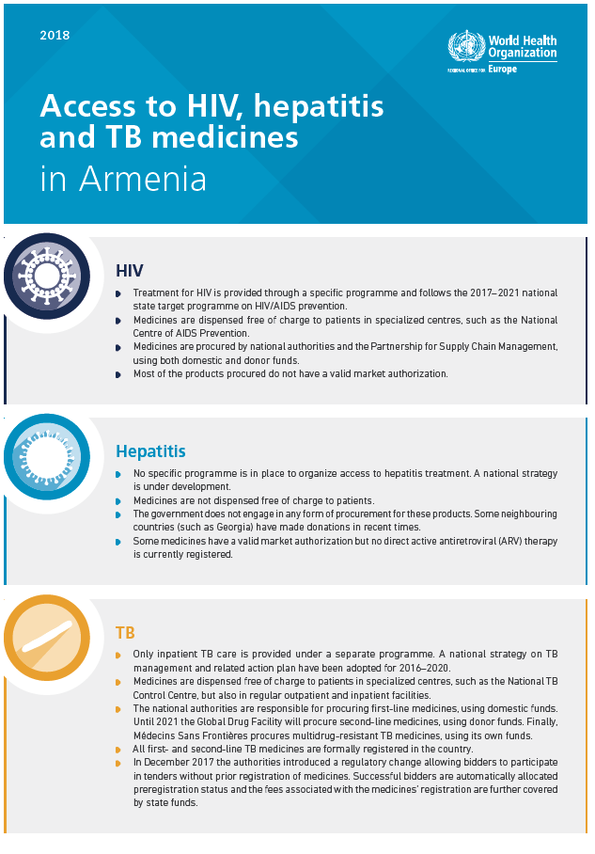
medicines

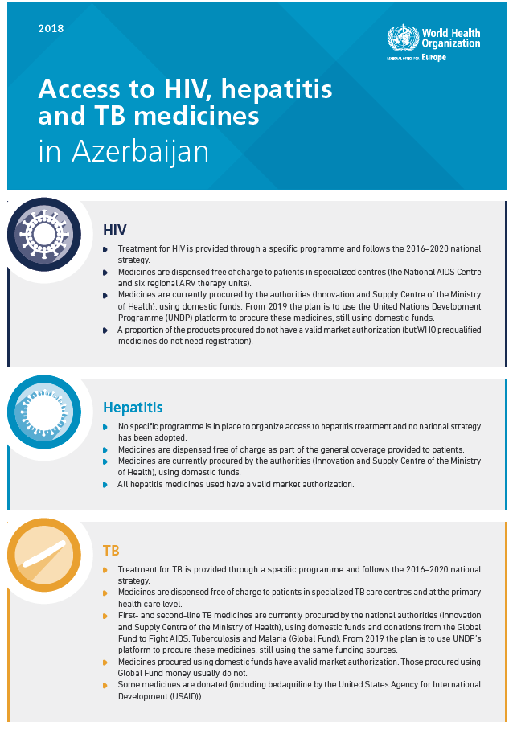
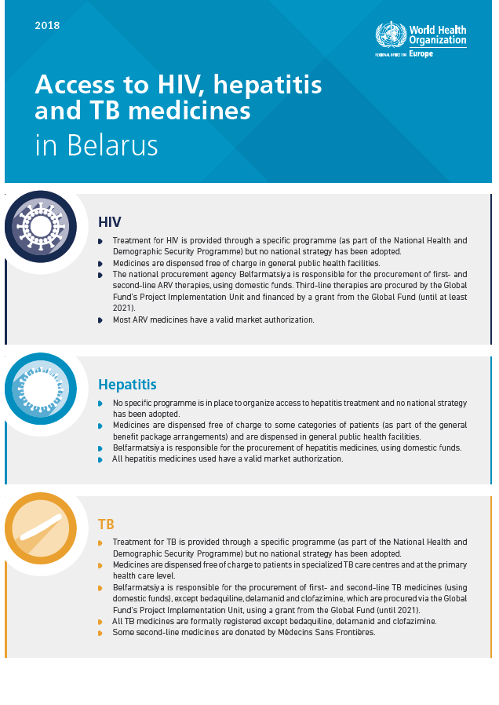
18

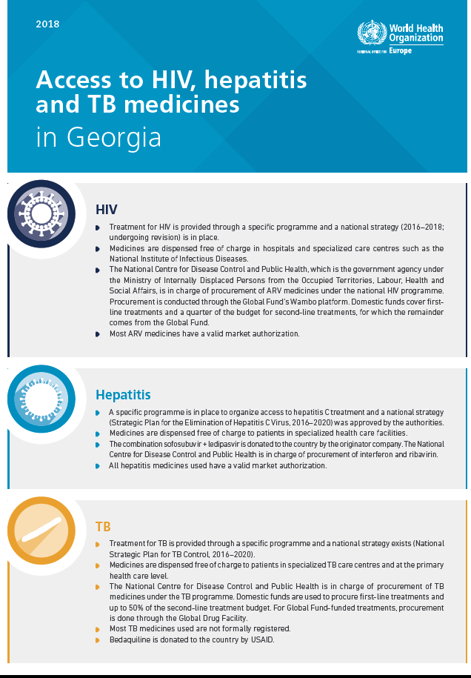
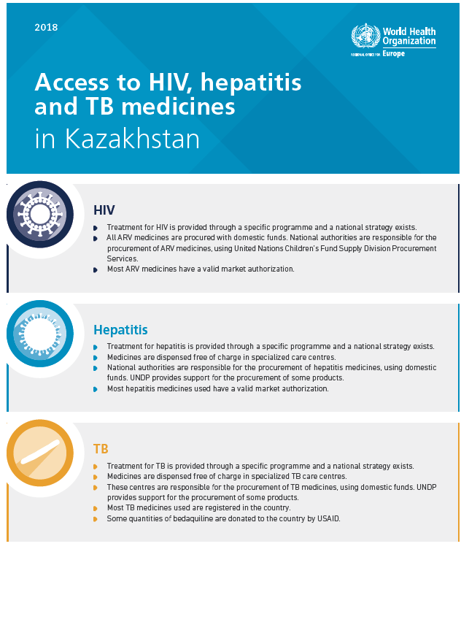
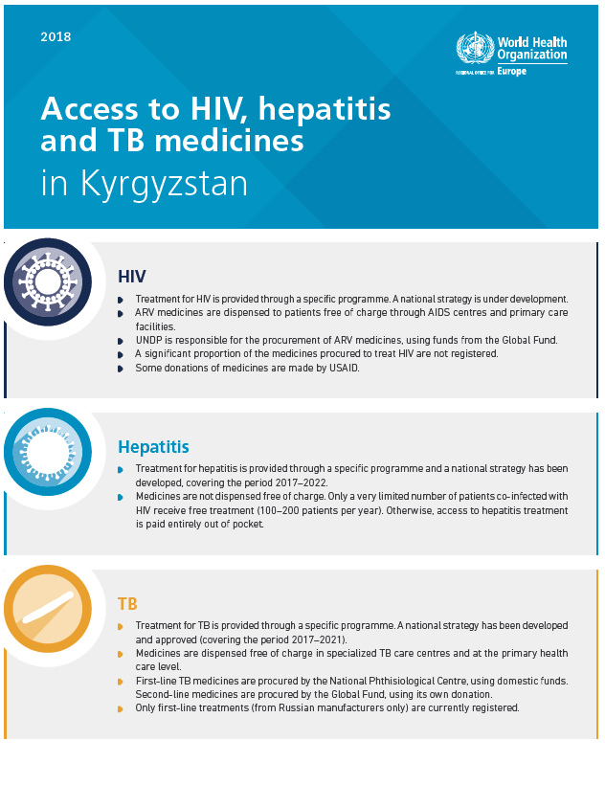
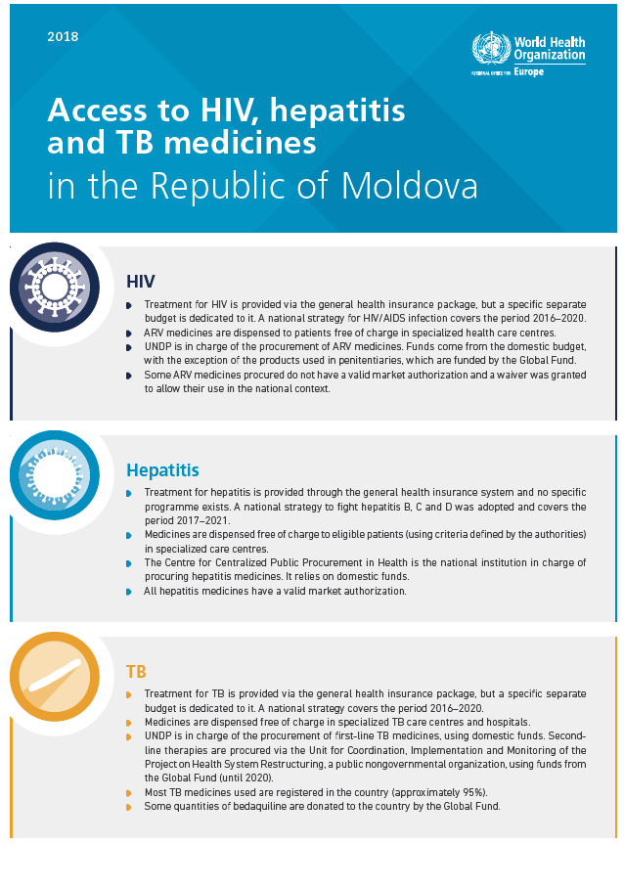
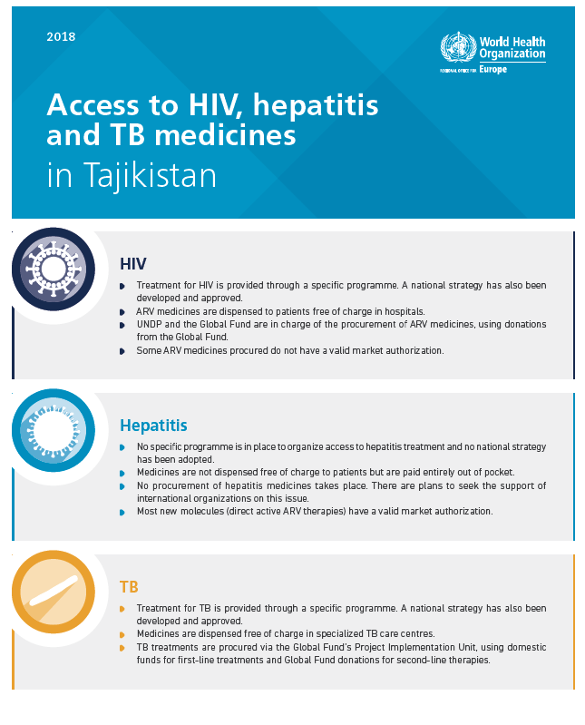
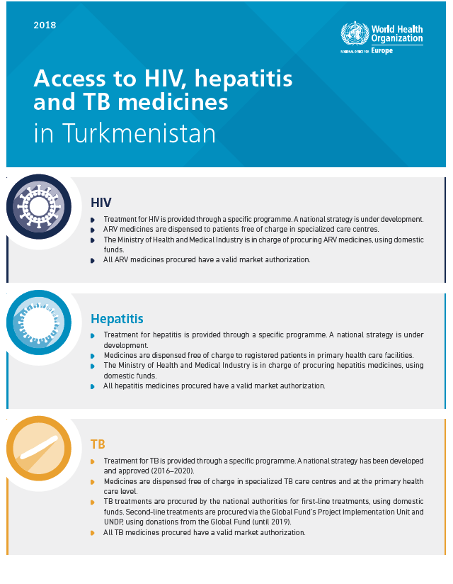
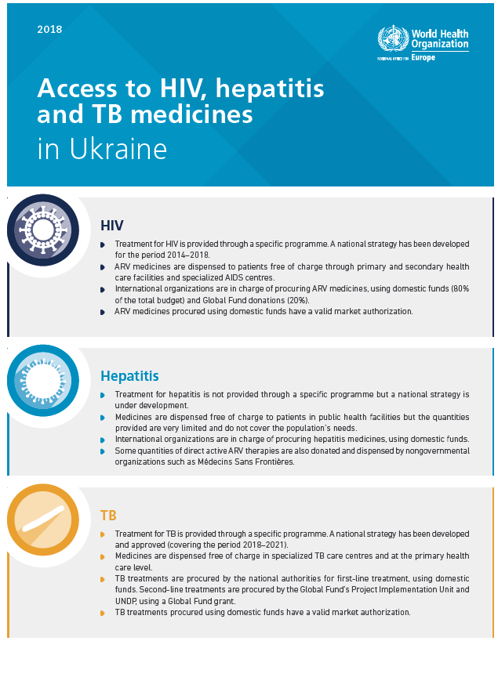
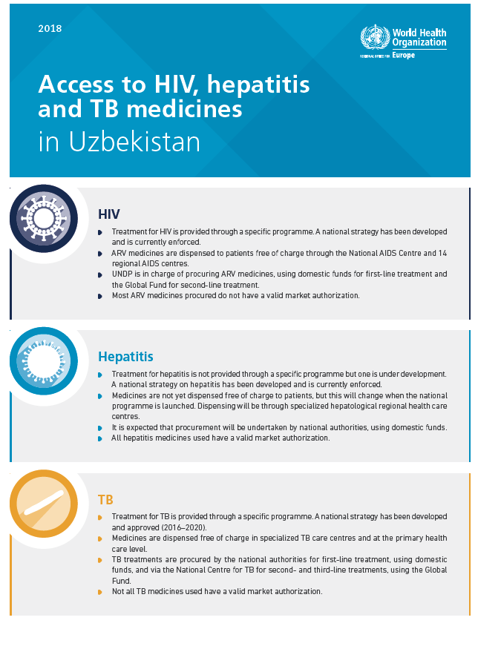

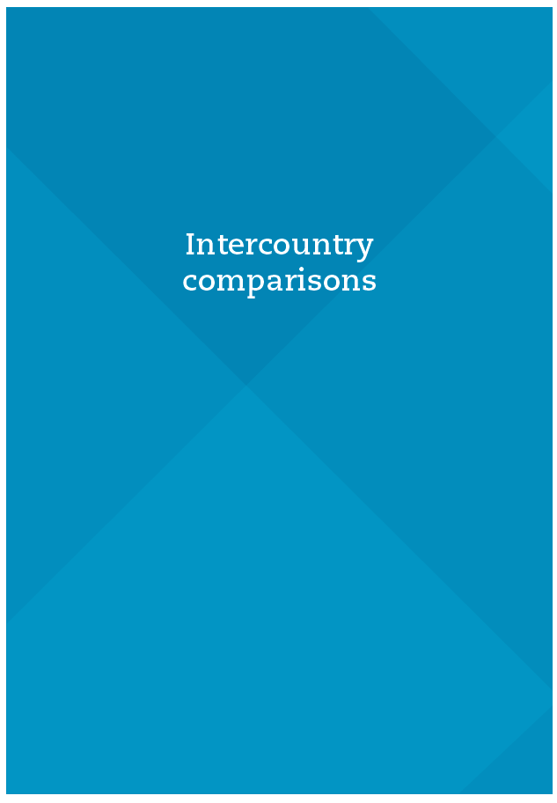
Intercountry comparisons

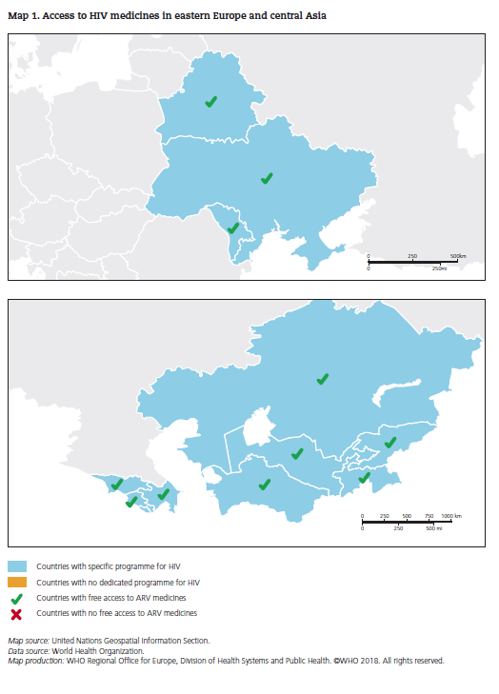
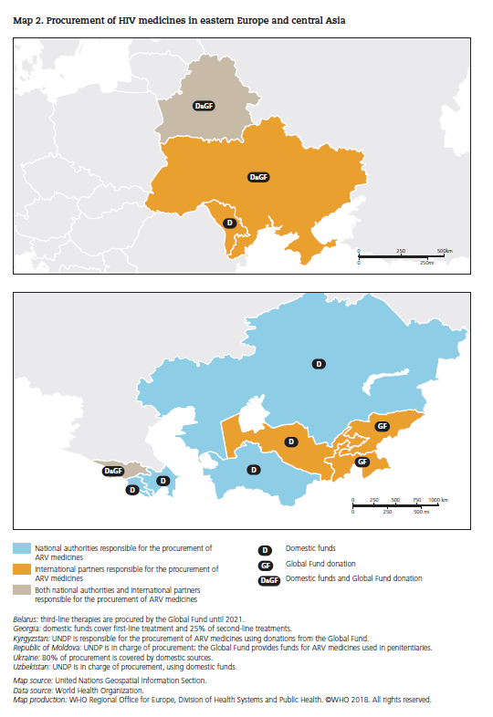
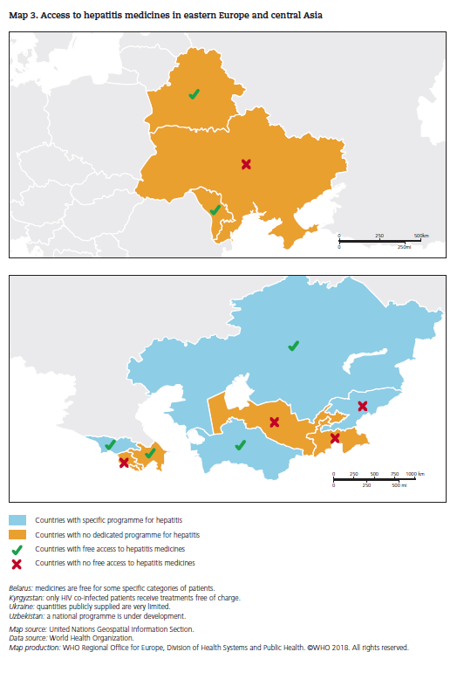
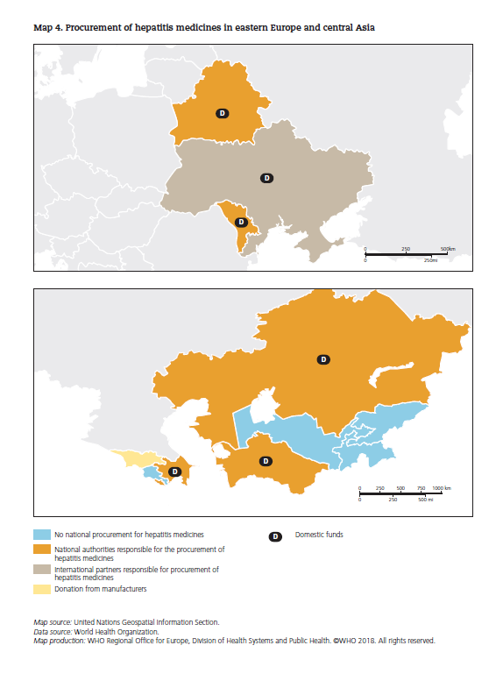
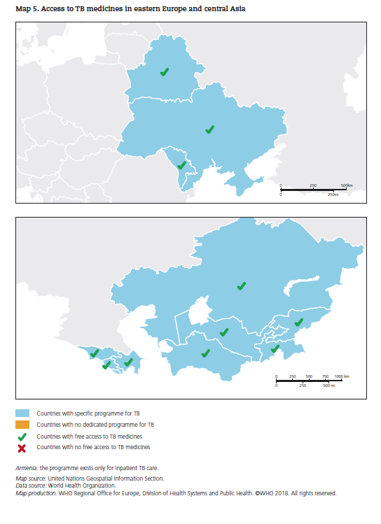
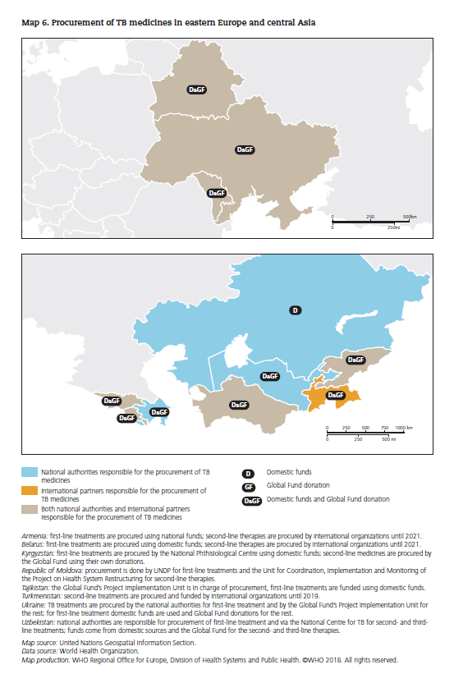

Not all countries within the CIS PPRI network are formally members of the CIS: Turkmenistan is an associate member and Georgia and Ukraine withdrew their participation. Nevertheless, the name was retained for simplification purposes, both for the network itself and when referring to it in this report.
The working document did not contain information on Georgia, which submitted its PPRI country profile in September 2018.

